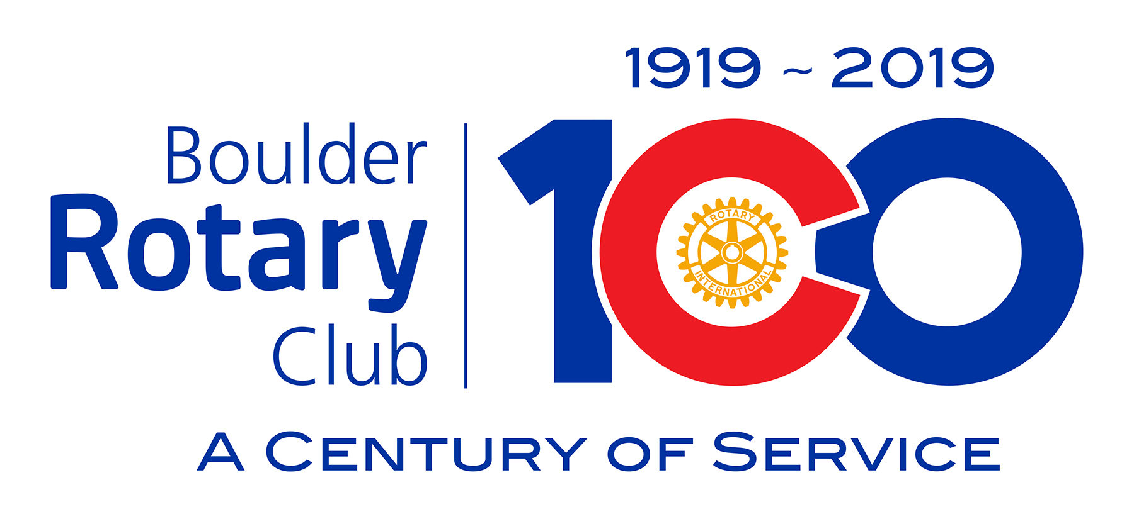
A Century of Service … what a milestone for the Boulder Rotary Club! To mark the 100th anniversary of the founding of the Club in April, 1919, Boulder Rotary has set a goal of raising $100,000 to fund the good works of the Club, both now and in the future. In our centennial year, we will sponsor several significant community projects that align with Club initiatives in the areas of peacebuilding, water and sanitation, and mental health. These projects include:

- Expansion and renovation of the Peace Park in the Boulder Civic Area, originally created by the Boulder Sister Cities Program ($30,000);
- Installation of water bottle filling stations in the Civic Area, the East Boulder Recreation site, and Scott Carpenter Park ($15,000); and
- A Mindfulness Garden at the new BCH Behavioral Wellness facility ($50,000).

A Centennial Fund is being established at the Boulder Rotary Club Foundation (BRCF) to raise funds for these projects, and to contribute to the longer-term financial sustainability of our Club’s mission as we move into our next Century of Service. Funds raised in excess of the committed $95,000 will be available to support the good works of Boulder Rotary well into the future.

To mark the significance of the year of our founding,1919, we are asking you to consider a donation in the amount of $1919. Donors who contribute this amount (or greater) to the Foundation will be recognized as founding members of “Club 1919” and will be honored guests at a Club 1919 dinner hosted by Gary Berg at The Academy in September. To reach our goal, we need at least 30 founding members of Club 1919.

Our goal for this fundraising campaign is 100% participation from Club members. We recognize that not all will be able to donate at the $1919 level, and other donations will be solicited at lower levels in the coming months. All contributers will receive a special recognition pin.

As an incentive to contribute early, the Boulder Rotary Club Foundation (BRCF) has agreed to match the first $50,000 we raise, and these funds will support the centennial projects described above.

Please consider becoming a charter member of Club 1919!

The Centennial Fund Committee
Gary Berg
Jon Kottke
Lenna Kottke
Danny Lindau
Darla Schueth

